COMPUTER SCIENCE
GRADE 7
SAMPLE ITEMS

Grade 7 Contents
Domain A: ICT Fundamentals 2
[SLO: CS-07-A-01] 2
Formative Assessment: 2
Summative Assessment: 3
[SLO: CS-07-A-02] 4
Formative Assessment: 4
Summative Assessment: 5
Domain B: Digital Skills 6
[SLO: CS-07-B-01] 6
Formative Assessment: 6
Summative Assessment: 6
[SLO: CS-07-B-02] 8
Formative Assessment: 8
Summative Assessment: 8
Domain C: Algorithmic Thinking and Problem Solving 9
[SLO: CS-07-C-01] 9
Formative Assessment: 9
Summative Assessment: 9
[SLO: CS-07-C-02] 10
Formative Assessment: 10
Summative Assessment: 10
Domain D: Programming 11
[SLO: CS-07-D-01] 11
Formative Assessment: 11
Summative Assessment: 12
[SLO: CS-07-D-02] 13
Formative Assessment: 13
Summative Assessment: 13
Domain E: Digital Citizenship 14
[SLO: CS-07-E-01] 14
Formative Assessment: 14
Summative Assessment: 14
Domain F: Entrepreneurship in Digital Age 15
[SLO: CS-07-F-01] 15
Formative Assessment: 15
Summative Assessment: 15

Thematic area:

Domain A: ICT Fundamentals

[SLO: CS-07-A-01]
Students will be able to identify the use of emerging technologies in various walks of life (e.g., artificial intelligence, biometrics, robotics, computer-assisted translation, 3D and holographic imaging, virtual reality, Cloud Computing, and open-source software.
Cognitive Level:
Knowledge

Formative Assessment:
(Marks :05)
The following worksheet comprises of pictures of different emerging technologies i.e., Artificial Intelligence, biometrics, robotics, computer assisted translation, 3D and holographic imaging, virtual reality, cloud computing, open-source software. Write down the name of respective emerging technology.
Picture | Technology Name
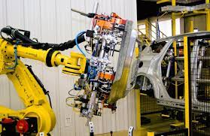





Scoring scheme:
01 mark for each correct identification

Summative Assessment:
(Marks: 05)
Name the emerging technology used in following scenarios from the given list:
(Artificial Intelligence, biometrics, robotics, computer assisted translation, 3D and holographic imaging, virtual reality, cloud computing, open-source software)
- Playing online games
- Detection of traffic congestion at different places
- MRI/ ultrasound scanning for disease diagnosis
- Handling of meeting conducted by business company that target audience who speak different languages
- Freedom to upgrade software for your business
Scoring scheme:
01 mark for each correct identification

Thematic area:
Domain A: ICT Fundamentals

[SLO: CS-07-A-02]
Students will be able to identify (advanced) hardware components of a computing system (e.g., different types of I/O ports, different types of peripherals, and networking components).
Cognitive Level:
Knowledge

Formative Assessment:
(Marks: 15)
The following worksheet has pictures of different devices. Categorize the devices into their relevant groups by mentioning serial number and name:
-  2. 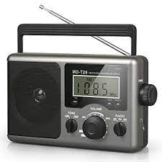 3. 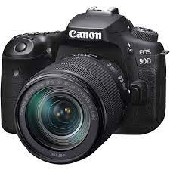 4. 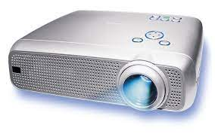
5. 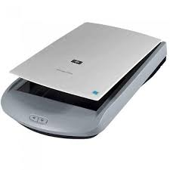 6.  7. 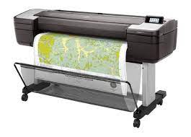 8. 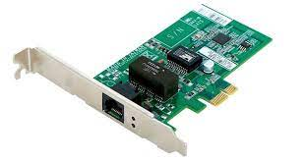
9. 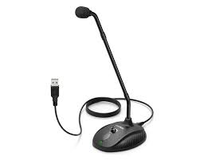 10. 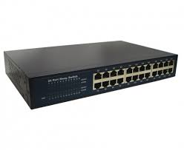 11.  12. 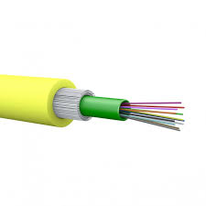
13. 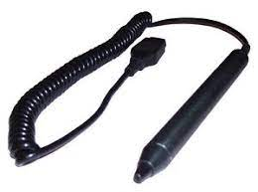 14.  15.  16. 
Input devices | Output devices | Network devices

Scoring scheme:
01 mark for each correct categorization of picture

Summative Assessment:
(Marks: 08)
Label the following ports:
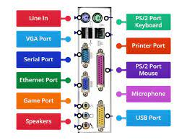

Scoring scheme:
01 mark for each correct labelling of picture

Thematic area:

Domain B: Digital Skills

[SLO: CS-07-B-01]
Students will be able to develop and demonstrate word-processing and presentation skills (using various software tools e.g., MS Word, MS PowerPoint, Prezi, Canva, Photo Story, Moviemaker, etc.)
Cognitive Level:
Application

Formative Assessment:
(Marks: 10)
Prepare a Power Point presentation in computer lab on any topic assigned by teacher using following features:
- Includes 10-15 slides
- Different font styles
- Bullets
- Slide layout
- Background
- Transition
- Animation
- Sound effects
- Insert picture
- Slide theme
Scoring scheme:
01 mark for each correct feature

Summative Assessment:
(Marks: 10)
Following are the two patterns of the MS-Word document, one is unformatted and other is formatted. Write down the steps to prepare the formatted document by mentioning the related features. (at least any five features)
- Unformatted document
Information technology (IT)
Information technology (IT) is the use of computers, storage, networking and other physical devices, infrastructure and processes to create, process, store, secure and exchange all forms of electronic data. Typically, IT is used in the context of business operations, as opposed to technology used for personal or entertainment purposes.

- Formatted document
INFORMATION TECHNOLOGY (IT)


Information technology (IT) is the use of:
- computers
- storage
- networking
- physical devices
- infrastructure
- processes

to create, process, store, secure and exchange all forms of electronic data. Typically, IT is used in the context of business operations, as opposed to technology used for personal or entertainment purposes.

Scoring scheme:
02 marks for each correct feature

Thematic area:
Domain B: Digital Skills

[SLO: CS-07-B-02]
Students will get introduced to electronic mailing systems (e-mail) and learn appropriate usage.
Cognitive Level:
Comprehension

Formative Assessment:
(Marks: 05)
Send an email to your class teacher that requests leave for two days. Also copy email to your subject teachers. Use following features of email:
- To
- From
- CC
- Subject
- Message
Scoring scheme:
01 mark for each correct feature

Summative Assessment:
(Marks: 05)
Describe the following parts of an email:
- To
- From
- CC
- Subject
- Attach file
Scoring scheme:
01 mark for each correct part

Thematic area:

Domain C: Algorithmic Thinking and Problem Solving

[SLO: CS-07-C-01]
Students will be able to apply the concept of computational thinking to handle complex problems.
Cognitive Level:
Application

Formative Assessment:
(Marks: 08)
Find a solution of a problem that displays the smallest number out of three numbers by using computational thinking approach.
Scoring scheme:
02 marks for Decomposition of problem
02 marks for Abstraction of problem
02 marks for Pattern recognition of problem
02 marks for Algorithm design of problem

Summative Assessment:
(Marks: 08)
Write down steps of computational thinking to solve the following problem:
A painter wants to determine the quantity of paint needed to paint only the walls and the interior side of the door in a room. The chosen paint covers 200 square feet per gallon. There are two windows. Use the following data to solve the problem:
- The room is 15 feet long, 12 feet wide and 10 feet tall
- The two windows are 6 by 4 feet, and 7 by 3 feet, respectively.
Scoring scheme:
02 marks for Decomposition of problem
02 marks for Abstraction of problem
02 marks for Pattern recognition of problem
02 marks for Algorithm design of problem

Thematic area:
Domain C: Algorithmic Thinking and Problem Solving

[SLO: CS-07-C-02]
Students will be able to apply concepts of conditional statements, finite and infinite loops to write different algorithms.
Cognitive Level:
Application

Formative Assessment:
(Marks: 08)
Write down an algorithm that displays the sum of first hundred even numbers.
Scoring scheme:
03 marks for correct use of sequence of steps
03 marks for correct use of input/output
04 marks for correct use of controls

Summative Assessment:
(Marks: 10)
Write down an algorithm that takes an integer number and prints its table by using loop. the algorithm will terminate if input number is zero (0).
Scoring scheme:
03 marks for correct use of sequence of steps
03 marks for correct use of input/output
04 marks for correct use of controls

Thematic area:

Domain D: Programming

[SLO: CS-07-D-01]
Students will be able to explain how computers encode and decode computer programs (i.e. identification of decimal to binary and vice versa, conversion of texts, images and sounds in binary).
Cognitive Level:
Comprehension

Formative Assessment:
(Marks: 10)
Complete the following worksheet:
- that convert a binary number into decimal number system
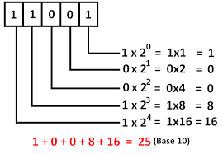

- that convert a decimal number into binary number system
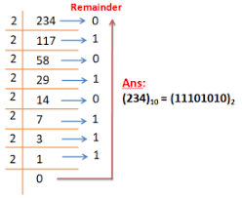
Scoring scheme:
01 mark for each box

Summative Assessment:
(Marks: 12)
Convert the following into respective number system:
- ( 10111101 )₂ ( ? )₁₀
- ( 00001 )₂ ( ? )₁₀
- ( 96000 )₁₀ ( ? )₂
- ( 23456 )₁₀ ( ? )₂

Scoring scheme:
03 marks for each part with complete steps

Thematic area:
Domain D: Programming

[SLO: CS-07-D-02]
Students will be able to apply fundamental programming constructs to create multi-sprite, multi-script programs using visual programming tools.
Cognitive Level:
Application

Formative Assessment:
(Marks: 10)
Develop a ‘Jumping Chick and Egg’ game using visual programming tools that creates and move characters.
Scoring scheme:
03 marks for correct use of sequence of steps
03 marks for creation/ movement of characters
04 marks for correct use of controls

Summative Assessment:
(Marks: 10)

Write a program using visual programming tools to show the dialogue between two friends on the topic of ‘ Ethics ’.

Scoring scheme:
03 marks for correct use of sequence of steps
03 marks for creation/ movement of characters
04 marks for correct use of controls

Thematic area:

Domain E: Digital Citizenship

[SLO: CS-07-E-01]
Students will identify ways to protect against malicious activities or behaviors in the digital environment.
Cognitive Level:
Knowledge

Formative Assessment:
(Marks: 05)
Write down any five preventive measures from malicious attacks.
Scoring scheme:
01 mark for each measure

Summative Assessment:
(Marks: 03)
What is malicious software? List any four malicious software.
Scoring scheme:
01 mark for definition
02 marks for correct names

Thematic area:

Domain F: Entrepreneurship in Digital Age

[SLO: CS-07-F-01]
Students will analyze the uses and benefits of design thinking for entrepreneurs.
Cognitive Level:
Application

Formative Assessment:
(Marks: 10)
An educational entrepreneur needs to develop classroom seating plan to conduct midterm examination of two different grades i.e., grade 6 and grade 7 in one room. Seating plan should accommodate approximately fifty (50) students in such a way that no two consecutive students are of same grade.
Instructions:
Draw a seating plan on paper by labelling the steps of design thinking process.
Scoring scheme:
02 mark for each step

Summative Assessment:
(Marks: 05)
Analyze the steps of design thinking process with the help of example.
Scoring scheme:
02 marks for each step

